Practical No. 10
Aim : 1) Write a program to implement user defined packages in terms of creating a new package and importing the same.

Name : Danish Altaf Solkar | Class : CO - B
Enrolment no. : 24111590805 | Batch : 2

Steps :-
- Check in Command Prompt:
java -version
javac -version

- Create a folder anywhere (for example on Desktop).
Example:
JavaPrograms
- Create the Package Folder
Inside JavaPrograms, create a folder named exactly like the package named myinstitute

- Inside the myinstitute folder create the file hello.java
package myinstitute;

public class hello
{
public void disp1()
{
System.out.println("Hello");
}
}

- Go back to the JavaPrograms folder and create demol.java
import myinstitute.*;

public class demol
{
public static void main(String args[])
{
hello a = new hello();
a.disp1();
}
}
Open Command Prompt.
Steps:
- Press Windows + R
- Type cmd
- Press Enter
- Then type the following commands :
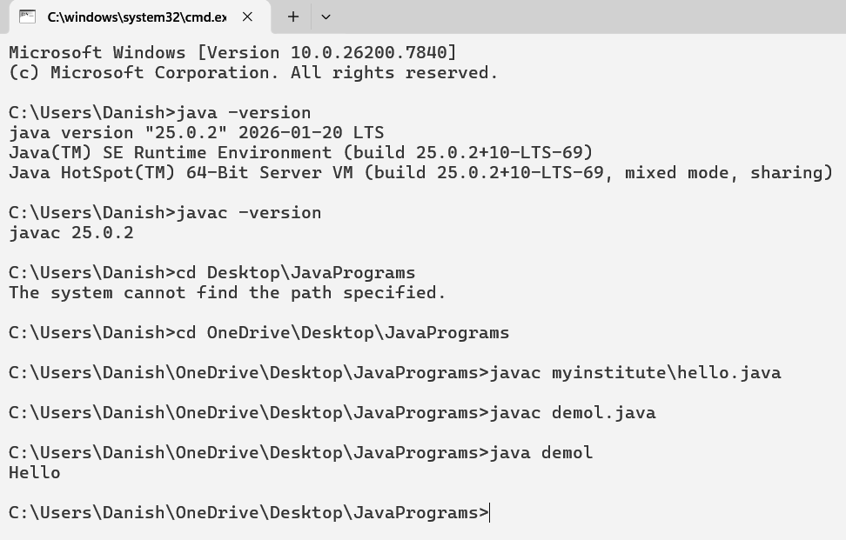

Aim : 2) Define a package named my Institute include class named as department with one method to display the staff of that department. Develop a program to import this package in a java application and call the method defined in the package Program

Steps :-
- Create a file Department.java inside folder myinstitute
package myinstitute;

public class Department
{
public void display()
{
System.out.println("Java taught by: Iffat Mam");
}
}

- Create a file packagedemo.java outside the package folder
import myinstitute.Department;

public class packagedemo
{
public static void main(String args[])
{
Department d = new Department();
d.display();
}
}

- Open Command Prompt
Steps:
- Press Windows + R
- Type cmd
- Press Enter
- Then type the following commands :
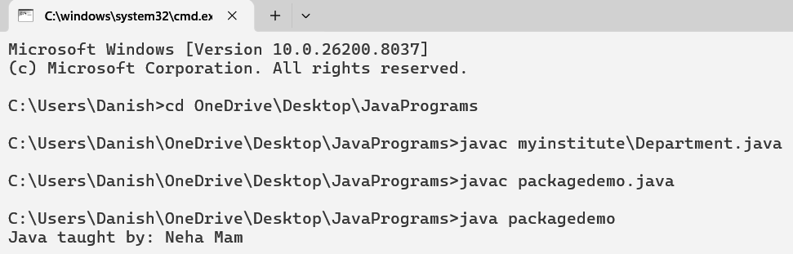

Aim : 3) Develop a program which consists of the package named let_me_calculate with a class named Calculator and a method named add to add two integer numbers. Import let_me_calculate package in another program (class named Demo) to add two numbers.

Steps :-
- Create a folder let_me_calculate

- Create a file Calculator.java
package let_me_calculate;

public class Calculator
{
public void add(int a, int b)
{
int sum = a + b;
System.out.println("Addition: " + sum);
}
}

- Create another file Demoo.java outside the folder
import let_me_calculate.*;

public class Demoo
{
public static void main(String args[])
{
Calculator c = new Calculator();
c.add(10,20);
}
}

- Open Command Prompt
Steps:
- Press Windows + R
- Type cmd
- Press Enter
- Then type the following commands :
